Team Number: 13

Team Name: GTRideShare

Transportation for Tech without the Wreck

Sally Park, Michael O’Mara, David Kim, Mylon Craig, Chris Yun, Jin Woo Lee

Part 4: Final Prototype Evaluation

**Executive Summary**

We are working on a rideshare design to connect Georgia Tech commuters who have similar schedules and destinations. While the majority of students do live on campus, there are still accommodations that can be made that will benefit both the environment and Georgia Tech students that do not live on campus. Single-rider commuters face the frustration of high gas prices, expensive GT parking passes, and what could potentially be a long and lonely commute with the high volume traffic within the city. While carpooling is a viable option to reduce the cost of the commute, carpooling options currently available to Tech students such as Uber, ZimRides, and the Carpool Parking Pass option fail to do so and therefore are either not used or not possible to be used due to being discontinued. These options are not popularly used by students due to either costing them more than if they were to commute alone, or because they require too much of an commitment and careful planning in order to be done comfortably. This design will target individuals within the GT community that struggle to find others to carpool with or help manage the carpool in an efficient manner with the option of potentially coordinating long term schedules. The design will do so by using profiles to share information about themselves to other students, connect students based on specific mutual characteristics, and utilize a carefully thought out method of sharing the cost of the commute rather than paying for a service. We hope to provide students with a superior alternative and fundamentally improve how carpooling is viewed by Tech students today.

Over the course of this project we were able to come up with solutions for the overall problem space discussed in the previous paragraph. We designed a system that would allow members of the Georgia Tech community to find others to carpool with as our solution provides users with the ability to find pre-existing carpool groups to join or filter through users to form their own carpool group based on any variety of schedules and preferences. Another component of our problem space was allowing those who already have carpool groups to manage their carpool group more efficiently. Our app provides a safe way for users to transfer compensation for gas and wear and tear to the drivers in the carpool group by providing a payment system that transfers funds from rider to the driver after a carpool trip has been confirmed to have ended by both the rider and the driver. Another way we help users manage their carpool groups is through a carpool agreement where users detail the rules for their carpool group such as where and when they meet, rules that should be followed in the vehicles, the separation of riders, and late policies. Through our solution, members of the carpool groups that violate the rules can be fairly handled using the late fee system included in the app to handle problems in regards to “Punctuality”; Additionally, users are given the ability to leave reviews and report members who behave inappropriately which can lead to severe forms of actions such as the removal of a specific user. However, from our user feedback, we found that there were some problems that we were unable to sufficiently handle. The first instance of this shortcoming was providing a sufficient incentive for users to be drivers in our system. Although we added in a system of points and financial compensation to incentivize drivers to use our app, members in our focus groups felt that they personally did not feel compelled to be a driver in our solution design. They felt that riders should pay for more than just 50% of the cost of the ride since drivers have to pay for maintenance costs such as wear and tear as well. Another issue that we had with our solution design was how complicated it was. We tried to add in as much functionality as possible to allow users to have the maximum level of control over their carpool experience, but participants in our focus group found our solution design too complicated to understand. So we still have to work on making this design intuitive for users.

**1. Stakeholders**

Our users can go from being the provider to the consumer at any given time.

* When users are providers:

Our users will go from consumer to provider and vice versa depending on whether they are driving or riding. Those who are driving at any carpool arrangement at any given time will be the providers. They provide a ride to and/or from the campus to the members of the carpool group. Providers become consumers when, depending on the carpool arrangement or being a member of different carpool groups in different days of the week, they share the ride someone else is driving.

* When users are consumers:

Those who ride are the consumers. In return for sharing the ride with the driver, they pay financial compensation for the driver’s gas for the particular trip. Consumers become providers when it is their turn to drive. Dependents, who do not own a method of transportation by themselves, will always be consumers.

* GT Parking and Transportation:

Another important stakeholder in our solution is GT Parking and Transportation Services. The department is much interested in providing an alternate method of commute to the members of GT community. Through an interview, Lisa Safstrom, Campus Transportation Planner in GT PTS, informed us of what the department would like to see on our solution. First of all, GT PTS wants to be informed of how effective our solution is. The effectiveness can be measured by the number of registered users, the number of active carpool groups and the actual number of daily commutes completed through carpool. Secondly, GT PTS reminded us of the security concern of a rideshare platform and requested a method to verify GT membership. An example it provided was requiring GT ID during registration.

Our final evaluation was focused toward our users as providers and consumers. Although GT PTS is an important stakeholder in our problem space and a likely partner in managing our platform, we concluded that the success of our core functionality as a rideshare platform for carpooling depends more on the experience of everyday users, who will use our solution to form, find and manage carpool groups, rather than the the administrative functionality that GT PTS is looking for. However, we shared GT PTS’s concern for user safety and made it one of our design criterias. As such, “Trust and Safety” is part of our final evaluation.

**2. Design Criteria**

1. **User Control**: Users should be presented with accurate information which they can use to make their desired type of carpool group, as well as be given the ability to customize said group.

This criterion was addressed and evaluated for this portion of the project in order to better understand whether users felt they had enough information and control when choosing to join or create a carpool group through our solution idea. This was evaluated primarily through the feedback received during our presentation in forms of either verbal feedback or our questionnaire. Success and failure concerning this specific design criterion was measured using the ratio of positive to negative feedback from users who interact with this solution. User feedback is absolutely necessary for deeming the success or failure of this design criteria as the user’s sense of control over their ability to customize their carpool group can only be measured through the feedback of said users. If the majority of the feedback received suggests, through either no responses or positive comments, that they feel they have been given a sufficient amount of user information and flexibility by the prototype of our solution when creating their carpool groups, then “User Control" will be marked as a success. If the majority of feedback received suggests, through comments about methods of what we can include or adjust in order to improve our design, then this design will be marked as a failure. We decided to define success and failure through the number of positive or negative feedback rather than the number of users providing them in order to handle situations where one user may provide both a positive and negative feedback.

1. **Punctuality**: Users should experience little to no delays when leaving and/or arriving to their destination in comparison to if they were to drive alone.

This criterion was addressed and evaluated for this portion of the project in order to better understand how users felt about our solution idea of utilizing a late fee penalty in order to discourage being late. This was evaluated primarily through the feedback received during our presentation in forms of either verbal feedback or our questionnaire. Success and failure concerning this specific design criterion were measured using the ratio of positive to negative feedback received from users who interacted with this solution. This criterion was determined a success if the majority of the feedback received suggests through either no responses or positive comments that they believed that the way our solution tackles “Punctuality” through initiating a penalty fee calculated by how late one is offers enough of an incentive for them to be on time. Accordingly, it was determined to be a failure if majority of the feedback received suggests through comments what we could include or adjust in order to improve our design. In order to avoid confusion possible with our previous method of measuring success and failure which relied on the number of users providing the feedback, the ratio of the type of feedbacks were used. By doing so, we could accurately handle situations when one user provides both a positive and negative form of feedback in order to more accurately determine success and failure.

1. **Trust and Safety**: Users should feel at ease when finding people to carpool with.

This criterion was addressed and evaluated for this portion of the project in order to better understand what users would require in order to be able to feel secure when using this solution idea. This was evaluated primarily through the feedback received during our presentation in forms of either verbal feedback or our questionnaire. Success for this criterion was determined by whether majority of the feedback received suggests through either no responses or positive comments on whether they believed that requiring specific information such as their active GTID and background history during registration as well as having rating system to continuously monitor their behavior was enough to provide them sense of security when using our solution. Accordingly, if majority of the feedback received suggested in forms of comments of what we could include or adjust in order to improve our design then the design would be marked as a failure. Success and failure was chosen to be defined through the number of specific feedback types rather than the number of users who provided them in order avoid special cases where a user may provide both a positive and negative feedback.

**3. Modifying the UI Based on Principles**

1. Minimization of on screen texts using plus-minus control
   1. There were too many texts on several screens, decreasing readability of information on screen and overall accessibility of the design. We changed the structure of several screens to hide the texts behind plus-minus controls, as below comparison demonstrates. In revised design, words don’t immediately overwhelm the user’s eyes and only appear when user wants them to.
   2. *Designing with the Mind in Mind* Chapter 4 Reading is Unnatural discusses how reading is a learned skill and how poor information design disrupts reading. We concluded that the small font and high word count at the center of the screen disrupted reading and needed changes.
   3. 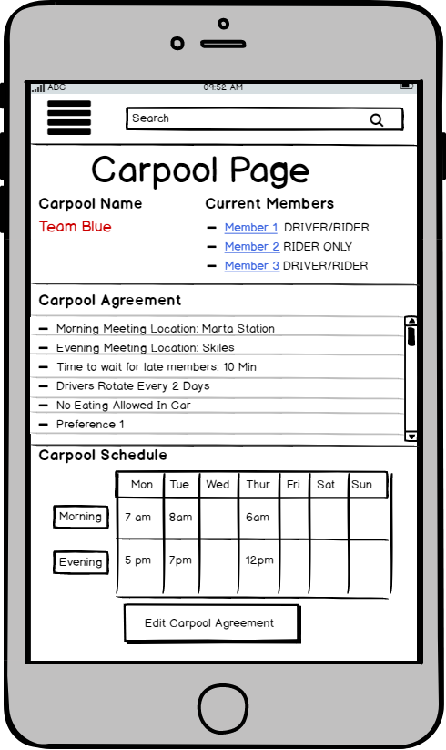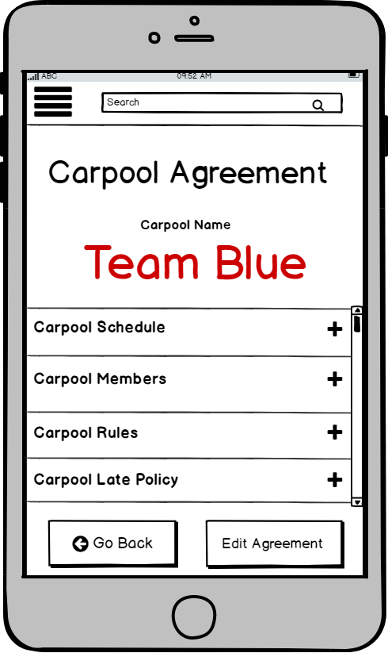

Before After

1. Search Filter Screen
   1. The name filter requires a user to type in while the other filter options are drop down menus from which a user chooses from. In order to properly group related objects together and separate objects that require different actions, a better layout of these filter boxes was needed. To fix this problem, we moved the name search box above the drop down boxes so that the visual separation of the different and the related provide immediate recognition of sub-grouping of related menus.
   2. Among several Gestalt Principles discussed in *Designing with the Mind in Mind* Chapter 2, the principle of proximity is the basis for this change.
   3. 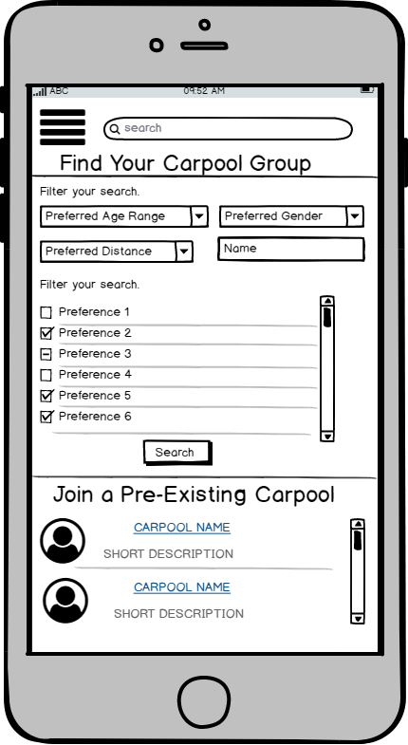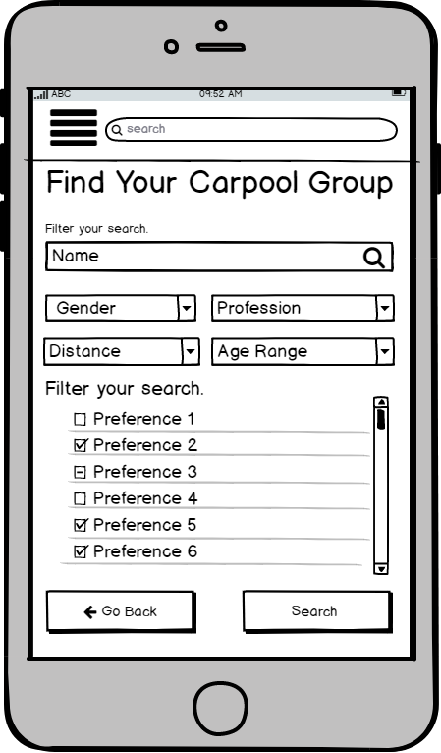

Before After

1. Button Sizes and Layout
   1. The location and size of some buttons with the same function were different across multiple screens. To resolve this issue, we relocated and and resized the buttons to be consistent across the screens. We also changed back button to be consistent throughout all screens as well.
   2. We base our change on perceptual priming discussed in *Designing with the Mind in Mind* Chapter 1; people rely on their past experiences of where things are and where they expect them to be.
   3. 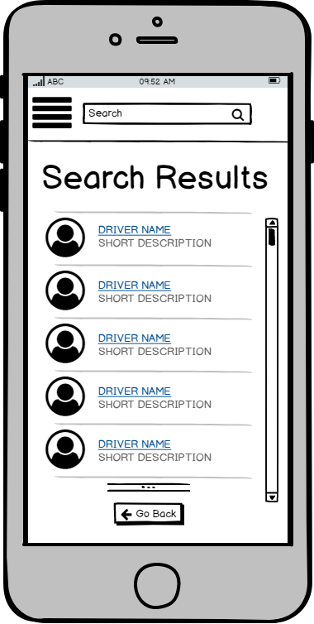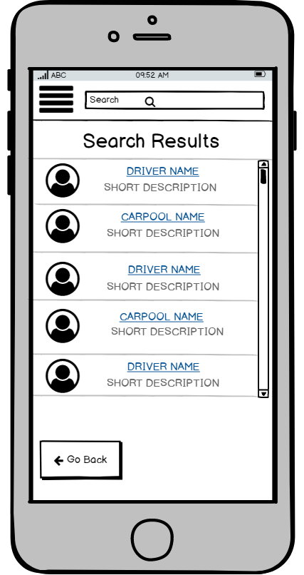

Before After

**4. Heuristic Evaluation**

1. In Appendix A, copies of the individual usability bug reports that were produced by each member of our design team are provided.
2. In this section, a ranking of the top 10 usability bugs that we recommend be fixed, based on the debriefing session done by our project team after the individual evaluations have been completed, is provided.

|  |
| --- |
| 1. Help users recognize, diagnose, and recover from errors - When users cancel their rides, there should be a confirmation message providing the user with a second chance to either decide for sure that they want to cancel their ride or to take back their decision without any immediate consequences. 2. Recognition rather than recall - In the state that our prototype is currently in, users are given the ability to review or send a formal complaint on their fellow carpool members. However, when users choose to leave reviews on their carpool members, they are immediately referred back to the homepage instead of again being given the option to report a user in their carpool group. Although the “report a user” option is included in the drop down menu that users can access at anytime, the option should be displayed when users might be most interested in using it instead of forcing users to refer back to previous screens.      1. Aesthetic and minimalist design - On the homescreen of our solution, there is a menu with a list of options for the user to choose from, but also on the homescreen (as well as throughout the rest of the app), there is a drop down menu option that lists these same options. So if we already have these options listed on the drop down menu, there is no need to clutter the home page with these options. So we should delete the duplicate home-screen menu. 2. Aesthetic and minimalist design - When a user is late to their carpool, the app will give them an alert detailing how much of a late fee will be added to their payment for the carpool ride, the payment that would be added if the user decided to cancel their participation in the specific carpool ride, as well as other information. But alerts are supposed to convey the most important information quickly so that a user can make a quick decision. So the alert as it is currently is too wordy and needs to be simplified 3. Recognition rather than recall - Currently, our solution only notifies users about their carpool when the user is late to arriving for the carpool. But rather than making users rely on their recollection of arranged meeting times, users should instead be provided with a reminder in the form of a notification a few minutes prior to the meet time. 4. Match between system and the real world - When users begin their carpool ride they can see the users that they’ve added to that specific carpool ride and they can go to the cost break down page to see how much compensation they’re receiving from each member and the points they’re receiving from the carpool ride as a whole. But currently we have this compensation “total” labeled as total profit. However, this implies that the purpose of this financial exchange is for the rider to make money off of the carpool, but the money that the carpool members earn is not enough to make a genuine profit. The purpose of this financial exchange is to compensate drivers for the wear and tear that carpooling has on their car as well as any gas costs. So the wording in the app does not match the real world solution. So the term should be changed from total profit to total compensation. 5. User control and freedom - Our solution allows users to initiate a carpool ride using their app. When they click on the carpool that they want to ride with they are given the option to start the ride as a driver or a rider. But if users accidentally press this button there is no way to go back to the previous screen as there is no back button included. This departs from the consistency found in the other screens throughout the app that provide the user with the option to navigate either backwards or forwards to certain pages. So for this page in particular we should provide the ability to go backwards via a back button. 6. Flexibility and efficiency of use - Currently when a user wants to join a carpool group that another member is in, they can join this member’s group through their user profile by clicking the plus button located under the list of group members. But this does not give members the option to join multiple groups at the same time. Users a required to complete the carpool process and press several back buttons to join an additional carpool group. So to rectify this, we should instead make it a check method so that if a specific user is involved in multiple groups a user is interested in, they can check all of them at once and press a single universal submit button to accomplish duplicate tasks at once and to further support consistency and standards of button location and functionality. 7. Consistency and Standards - When a user initiates a carpool ride without solution, a timer counting down until when the carpool group can leave begins. The format of the timer and the words that accompany the timer is confusing to understand. Although the time shown on the Carpool Roster page is related to the text below it, “minutes until departure”, the time is left aligned while the text supplementing it is right aligned making them seem as though they are unrelated when they actually are. 8. Flexibility and efficiency of use - Our solution requires the navigation of many screens in order to form or join a carpool group. To reduce the number of screens that novice users must navigate to from or join a carpool group, we should combine certain pages in order to create shortcuts. In our current solution, when a user is searching for a carpool group, they have to either choose between piecing together their own carpool group or creating their own. And after this choice, they are given a list of suggested carpools and/or carpool members. However, novice users of the app that may be unsure of whether or not they want to join a pre-existing carpool or create their own should be able to see a list of eligible carpools and drivers without having to make this choice. So a list of these drivers should be listed on the same page that the options are in order to reduce the number of required screens. |

**5. Focus Group Evaluation**

We aim to present our revised prototype to be evaluated by potential users in four categories: our three design criterias of User Control, Punctuality, Trust and Safety along with driver incentive. For each category we plan to evaluate whether they were properly addressed in our solution idea. Actual discussion questions used in the evaluation are presented in the Appendix B.

During the two 12 minute evaluations, we will present both focus groups with the same prototype in the form of a video. Following the presentation of the video, each focus group will be given the same survey type questionnaire. But the discussion questions these focus groups will be asked to focus on during our presentation will be different for each group.

For each focus group, we will begin by showing a 3 minute video that concisely introduces our project and provides an example walk-through of 2 basic benchmark tasks using our solution idea. Following the video, for each focus group, certain topics that we want to address in our discussion that are not shown in the video will then be explained to provide the users with enough insight into our idea so that they can properly convey their personal opinions in the form of feedback. In the first group, we will address the “User Control” and “Trust and Safety” design criterias. In the second group we will address “User Control”, “Punctuality”, and driver's incentive. We decided to divide and present our information in this form in order to maximize the amount of time we have to discuss topics that we find to be the highest in priority in regards to the matters that we want to receive feedback on. User control is covered twice because it is primarily what is shown in the video that will be presented to both focus groups. Once our users are presented with all the necessary information needed for the discussion, we will use the remaining time to collect any feedback outside the questions we plan to ask.

From the evaluation, we received valuable feedback from the users on our design. For user control, a participant in the focus group suggested a need for a “remove member” feature for carpool groups. For example, if a member of the carpool group is considered too uncooperative for the others, then a method to remove the uncooperative member may be needed. This removal can be accomplished through either majority vote or by the leader of the carpool group’s ruling. As for our driver’s incentive, we received feedback that the ratio we implemented to split the cost between the rider and the driver did not account for the additional costs needed to be paid by the driver for maintenance, for example: wear and tear. The general consensus in the focus group was that riders should collectively pay for more than fifty percent of the total gas and maintenance cost. For punctuality, the feedback was mostly positive; A late fee penalty was found to be enough to encourage punctuality. However, the late fee rate of 1% per minute was considered too low. A participant suggested that we adjust our late fee rate depending on the degree to which being late affects the arrival time based on whether the additional time the carpool must spend waiting for the late member means that the carpool group avoids or gets stuck in traffic that they normally would have missed. For the feedback on the general design of our solution, we have received constructive criticism that both our wireframe and our design are too complicated. Overall, the evaluation was a success because it brought to our attention several shortcomings in our design that we may have never found for ourselves. With the feedback obtained through our focus groups, we are reminded that there are further improvements that can be made to more accurately accommodate the needs our of users.

**6. Reflection**

**Preparation**

* How well, and in what ways, do you think your efforts in Parts 1-3 informed your activities in Part 4?

Parts 1 through 3 definitely had a huge contribution to how informed we were for the activities in Part 4. The in-class activities gave us a firmer grasp of how specifically to transition from an accumulation of raw data that we receive as feedback and/or reviews into concrete solution implementations. An example of this would be the use of affinity diagrams and the concepts that we learned from the affinity diagramming process such as recognizing the common goals of features definitely came in handy when refining the prototype in this deliverable. Additionally, focusing on the stakeholders in each deliverable of this project kept us in check in terms of how we addressed the problem space. There were several occasions when we wanted to add or remove features from our solution design; however, we made sure to prioritize the stakeholder when making any decision in regards to altering our solution design in anyway. Also having the TA's and Professor’s reviews and feedback from the previous deliverables helped us to build and refine upon our solution ideas into the final prototype. Shortly put, everything in P1 through P3 helped prepare us get to this point in our solution.

* What aspect of the class so far best prepared you for this project?

The aspect of the class we found so far that best prepared us for this project was how we prioritized on developing the problem space before thinking of various solutions to our project. The reason being that we were able to expose ourselves to many key ideas and problems that needed to be taken into consideration when approaching this project as a whole; which, we may have never known about if we were to not have done so. Focusing on the problem space directly correlated to the proper construction of our design criterias which again was directly correlated to creating solutions that properly handle the problems experienced by realistic users of our design. Ultimately, we chose focusing on the problems space to be the most important aspect because as stated, it acted as a solid building block in the construction of a strong and healthy solution.

* On what aspects do you feel you most needed better instruction to perform correctly?

When we were coming up with the structure for our focus group, we struggled the most when it came to the creation of the focus group questions. Since we were the last to present, we saw how previous presentations included discussion questions that got no responses because of the poor construction of their questions. And these groups that had poor questions wasted most of their time sitting around waiting for a brave member of the focus group to respond. We did not want to waste this time; we instead, wanted to make sure that we got ample feedback on each of our design criteria and focused areas. We were extremely nervous that we would ask a question we really needed to know the answer to, but no one would respond. If we had been taught more information about how to properly structure focus group questions that break the ice and the proper way to implement follow up questions to get an appropriate response, we would have been more prepared to conduct more effective focus groups.

**Lessons learned**

* What parts of your final design do you think show evidence of being a successful solution to the problem you focused on?

We sought to provide a reliable alternative method of commuting to the members of the GT community. To define a successful solution, we must first go back to the problem space. During the first deliverable of this project we conducted interviews to define what the problem space was in the first place. Many of the interviewees expressed that they would be interested in carpooling, but that they did not personally know anyone that they could carpool with. This feedback alerted us to a real problem that needed to be addressed during the creation of our solution. We then, with an idea of our problem space, designed a system that would allow its users to find others to carpool with, to find pre-existing carpool groups to join or to filter through users to form their own carpool group based on any variety of schedules and preferences. Additionally, from our research we find a need to provide an efficient way to manage carpools created by acquaintances outside our design. Once we had achieved this, we had received continuous feedback throughout the semester in order optimize our approach to these problem. Through this strenuous process we were able to succeed in developing for example an early model of a viable driver incentive program.

* What parts of your problem still do not have a sufficient solution based on your design solution?

According to the feedback we received during our focus group evaluation, our user interface was considered too complicated by the majority of users. If efficiency of managing carpool groups can be measured in part by its ease of use, our complicated interface fails to provide an effective way to manage carpool groups. Another problem in our solution design can be found in how we handle late carpool members. Although members of the focus group actually liked that we implemented a penalty for late carpool members in the form of a late fee, they did not believe that the severity of the late fee that we used was sufficient. We presented the focus group with a late fee of one percent of the entire carpooling cost that increases by one percent for every minute that the user is late. Although we have received a suggestion on how to improve the late fee feature, we are still unsure of the optimal method of doing so. The last problem we feel we did not properly address in our design solution is an appropriate driver’s incentive. We received the suggestion of increasing the ratio that the rider pays in comparison to the driver to compensate for wear and tear of their vehicle. Although, this is an interesting solution, we again have not sufficiently explored this topic enough to say that, it would be the optimal method.

* If you were to do this project all over again, how would you do it differently?

We would redo the video and show less functionality for the sake of increasing clarity to the audience. While we believed the system was well thought out, most of the feedback relayed that the system was too complicated and that its complexity would prevent them from using the system. Rather than focusing on showing all possible functionality, we would focus on a particular set of features for creating the carpool group. This would have improved the presentation of our design to the focus group as the tasks presented to the participants of the focus group would be a lot clearer to follow and ultimately easier to give feedback on. Overall, while the design was very detailed and addressed most of the issues users might possibly face, the solutions themselves could have been developed more to reflect the user’s interests. During our discussion groups, the main points of larger driver incentive and a complicated user interface were repeatedly brought up, and were we to do the project again, we would fully develop satisfactory solutions to these main issues before addressing other issues, such as user control and a late penalty.

* What do you think about this semester’s design problem of the “shared economy”? Was it a good topic for you to learn the principles and processes of human-centered design?

“Shared Economy” as the design problem forced us to constantly revisit the identification of consumers and producers within out problem space. The constant need to check that every decision we make meets the needs and the wants of the users demanded extra care especially for our solution since the role of consumer and producer was not fixed but flexible. That extra care required for our solution pushed us to always keep the role and relationship of consumer and producer in every step through human-centered design process. But it also made it difficult for the first half of the project to only focus on the problem space, as each area of the problem space involved the ideas of potential solutions.

**Appendices**

1. Raw data from Heuristic Evaluation

|  |
| --- |
| **Evaluator**: Jin Woo Lee  **Heuristic(s) violated**: Match between system and the real world  **Brief description of the issue raised**: On carpool roster screen of SB 2, word choice of “total profit” is confusing. What profit? Whose profit?  **Severity**: 2  (0 to 4, where 4 is most severe, based on frequency of occurrence, impact on user experience, persistence of issue with increased use of prototype, and market impact)  -----------------------------------------------------------------------------------------------------  **Heuristic(s) violated**: Help users recognize, diagnose, and recover from errors  **Brief description of the issue raised**: There is no interface implemented for error handling.  **Severity**: 3  -----------------------------------------------------------------------------------------------------  **Heuristic(s) violated**: Consistency and standards  **Brief description of the issue raised**: After the rider pays the ride with late fee included, the account balance is 7.5 higher than before the rider pays? Points to the same screen as driver.  **Severity**: 3  -----------------------------------------------------------------------------------------------------  **Heuristic(s) violated**: Consistency and standards  **Brief description of the issue raised**: Carpool rules or carpool agreement in carpool request form?  **Severity**: 2  -----------------------------------------------------------------------------------------------------  **Heuristic(s) violated**: User control and freedom  **Brief description of the issue raised**: There is no way to go back to previous screen(homepage) from “Create a Group” screen.  **Severity**: 3 |
| **Evaluator**: Michael O’Mara  **Heuristic(s) violated**: Aesthetic and minimalist design  **Brief description of the issue raised**:  One of primary issues with the wireframe design would be the amount of text on certain screens as this is not visually appealing. For example, Slide 4.2 has so much text that the visibility and overall readability is somewhat impaired.  **Severity**: 2  -----------------------------------------------------------------------------------------------------  **Heuristic(s) violated**: Consistency and Standards  **Brief description of the issue raised**:  One example which shows how consistency and standards are violated is the use of “carpool” and “carpool group” throughout the wireframe. On some slides “carpool” is used to describe a carpool group whereas in other slides “carpool group” is used to refer to the carpool group. For this reason it is best that only one of these descriptions is used for consistency reasons since this will result user confusion.  **Severity**: 2  -----------------------------------------------------------------------------------------------------  **Heuristic(s) violated**: Recognition rather than recall  **Brief description of the issue raised**:  One of the other issues would be recognition rather than recall. In the case that a user needs to report an individual, they will have to remember to go back and do the reporting after the fact. For this reason this heuristic is violated.  **Severity**: 1 |
| **Evaluator**: Sally Park    **Heuristic(s) violated**: aesthetic and minimalist design    **Brief description of the issue raised**: Extra menu screen on home page, change “back to home page” to “home”, Proximity – items are too grouped together    **Severity**: 2  (0 to 4, where 4 is most severe, based on frequency of occurrence, impact on user experience, persistence of issue with increased use of prototype, and market impact)    -----------------------------------------------------------------------------------------------------    **Heuristic(s) violated**: Help users recognize, diagnose, and recover from errors    **Brief description of the issue raised**: Late fee error message could be simplified    **Severity**: 1    -----------------------------------------------------------------------------------------------------    **Heuristic(s) violated**: Consistency and standards    **Brief description of the issue raised**: Merge “Report User” into “help button”      **Severity**: 1 |
| **Evaluator**: Mylon Craig  **Heuristic(s) violated**:Aesthetic and minimalist design  **Brief description of the issue raised**: The pages are often crowded on the home page and the page that you can search, but in order to give users control to allow them to use recognition over recall it’s hard to fix this overcrowding issue  **Severity**: 1  (0 to 4, where 4 is most severe, based on frequency of occurrence, impact on user experience, persistence of issue with increased use of prototype, and market impact)  -----------------------------------------------------------------------------------------------------  **Heuristic(s) violated**: Help users recognize, diagnose, and recover from errors  **Brief description of the issue raised**:  When users cancel their rides, they should be given options about how to handle it and also be told what the affect the money should have  **Severity**: 3  -----------------------------------------------------------------------------------------------------  **Heuristic(s) violated**: Recognition rather than recall  **Brief description of the issue raised**:  SB2 Slide 13:Rate Users doesn’t have a button that allows the user to go back because just incase they wanted to report a user The option is still available in the drop down menu, but it should be easily visible when the user might most want to use it  **Severity**: 2 |
| **Evaluator**: David Kim  **Heuristic(s) violated**: Consistency and Standards  **Brief description of the issue raised**:  Throughout the wireframe, button sizes and locations were varied making it hard for users to use the application in general, can’t build muscle memory as fast and will make it harder for user to get used to using the application, which may annoy them and reduce their comfortability when using this app.  **Severity**: 4  -----------------------------------------------------------------------------------------------------  **Heuristic(s) violated**: Flexibility and efficiency of use  **Brief description of the issue raised**:  Organization of inputted information when using the filter options available can be better organized where the different types of inputs can be separated as well as the having the most specific filter options be presented first in order to reduce the “work” required to look through all the options for experienced users.  **Severity**: 2  -----------------------------------------------------------------------------------------------------  **Heuristic(s) violated**: Aesthetic and minimalist design  **Brief description of the issue raised**:  On several pages, a lot of information is presented at once which may be overbearing for users in one way or another. If they were to want to find something they would have to go through tons of information to do so, and even if they were to find what they were looking for would have to make sure they aren’t led astray from the other information around it.  **Severity**: 3 |
| **Evaluator**: Chris Yun  **Heuristic(s) violated**: Aesthetic and minimalist design  **Brief description of the issue raised**: The design is too complicated and does not provide a simple solution to creating or joining a carpool group. The number of screens could be reduced or have less information be shown to make it simpler for the user.  **Severity**: 3  -----------------------------------------------------------------------------------------------------  **Heuristic(s) violated**: Recognition rather than recall  **Brief description of the issue raised**: Some of the pages do not provide a back button that will allow the user to return to the previous page.  **Severity**: 2  -----------------------------------------------------------------------------------------------------  **Heuristic(s) violated**: Help users recognize, diagnose, and recover from errors  **Brief description of the issue raised**: Users should be informed well before they are late the penalties that will occur, whether in a carpool agreement that the user agrees to when signing up or a warning message five minutes before the late-fee penalty will occur.  **Severity**: 1 |

1. Raw data from in-class focus group discussions

|  |
| --- |
| Notes Taken: **FOCUS GROUP 1**  Focus Questions:   * On Safety:   Do you feel our current method of safety is sufficient?  - lots of switching between pages, too complicated to follow  - on the page when you’re consumer choosing to join or create a carpool: what if you want to join a carpool and its empty, adding a back button.   * On Control:   Do you feel like you have control over users?  - no, can’t kick people out.   * On Driver Incentive:   Do you feel like the current incentive provided is enough?  - no still not clear  Asked by focus group:  Can you kick someone out of carpool group?  - Yes, in cases of harassment or breaking carpool agreement.  Can you reject people who want to join carpool group?  **FOCUS GROUP 2**  Focus Questions:  Is there enough incentive provided to become a driver?   * possibly change to 60:40 * having a discounted ride does not do anything * the penalty is too small   Asked by focus group:  Is wear-and-tear calculated into the algorithm? |
| Audio Recordings:   * Focus Group 1:   + <https://drive.google.com/open?id=1Jo_xvgdIeK5hiJJZmMrg8U8bHZN_GvP3> * Focus Group 2:   + <https://drive.google.com/open?id=1mq3kAEjtdZV6ZlZbZ8UOivRTpO1Nz_xk> |
| Written input from focus group: |